Wireframe document

Analyzing World’ Best Wine Reviews Dataset



Revision 1.2

Last date of revision-17.02.2025

Kashish Malviya

Document control

|  |  |  |  |
| --- | --- | --- | --- |
| Date | Version | Description | Author |
| 15.02.2025 | 1.0 | Introduction,  Problem Statement | Kashish |
| 17.02.2025 | 1.1 | Dataset Information,Architecture | Kashish |
| 20.02.2025 | 1.2 | Final Revision | Kashish |
|  |  |  |  |

**We performed Exploratory Data Analysis on Jupyter Notebook and then created a Power BI Desktop Dashboard.**

1.Which are the top 10 wine producing countries?

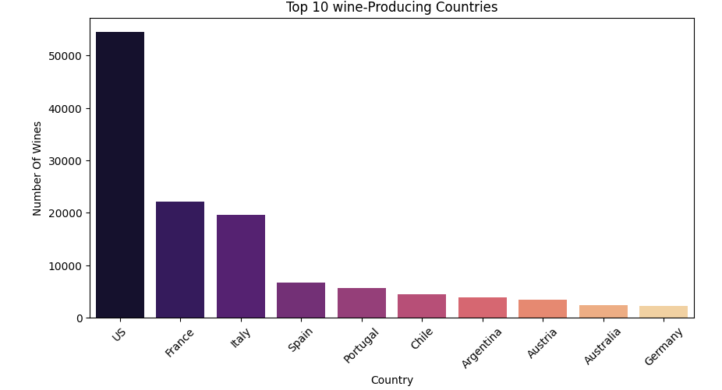ANS: US, France, Italy ,Spain , Portugal ,China, Argentina, Austria , Australia ,Germany

2.Price and quality difference

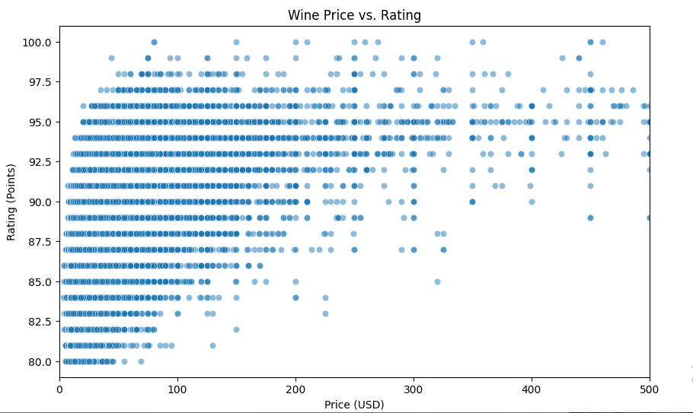

Which countries are having average wine rating?

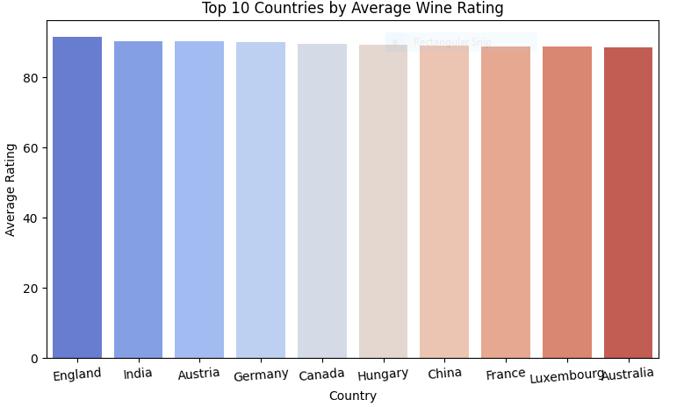

* England
* India
* Austria
* Germany
* Canada
* Hungary
* China
* France
* Luxembourg
* Australia

4. Which are the top 10 variety of wines?

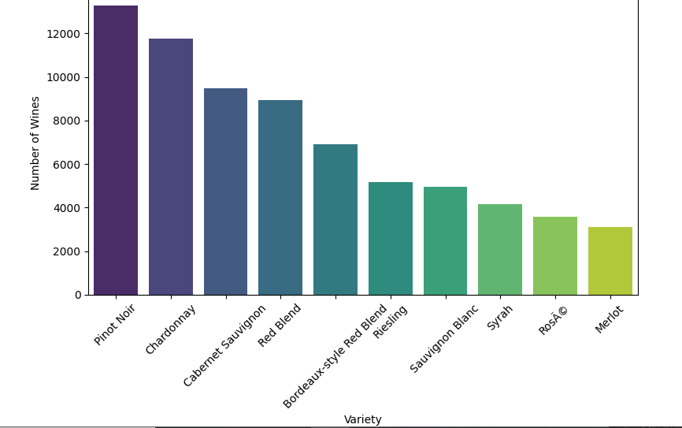

1.Pinot Noir 9 .ROSA

2.Chardonnay 10. Meriot

3.Cabernet Sauvignon

4.Red Blend

5.Bordeaux-style Red Blend

6.Riesling

7.Sauvignon Blanc

8.Syrah